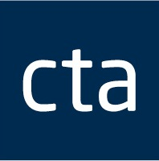

|  |  |  |
| --- | --- | --- |
|  | Shared Outcomes Document from the ATO & Corporate Tax Association (CTA) Workshops  All Public Groups and International (PG&I) and Indirect Tax Public Groups Engagement (PGE) staff  Thank you to all CTA members and ATO staff who participated in our jointly sponsored Justified Trust and Key Taxpayer Engagement workshops throughout 2017.  Together we hosted seven workshops, with over 172 CTA members representing more than 100 corporates and about 300 ATO staff in attendance. We also met with key advisors in early 2018 to discuss the impacts of Justified Trust and Key Taxpayer Engagement in the context of the workshop material.  An outcomes document addressing questions raised during the workshops has been progressing since early 2018. We have incorporated the practical feedback received into the final document that has been jointly endorsed by the ATO and CTA. The outcomes document can be found [here](http://corptax.com.au/wp-content/uploads/2018/04/CTA-ATO-Workshop-Document-24-April-2018.pdf%20).  We are proud to have jointly developed a practical document that can be shared by ATO staff, CTA members and other clients and we look forward to working together in 2018.  Warmest regards,  Michelle de Niese, Paul Suppree, Jennifer Moltisanti, Jeff Stevenson, Judy Morris, Belinda Darling, Michael Morton, George Montanez, Katie Welsh and Raj Srikhanta. |  |